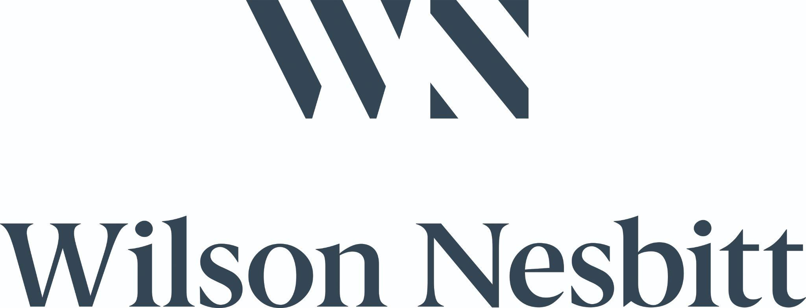

**Trainee Solicitor Three Year Programme**

Wilson Nesbitt seeks six law graduates for a three year training programme commencing September 2023 culminating in qualification as a solicitor on 1st September 2026.

Wilson Nesbitt is widely considered to be one of the most modern and progressive law firms in Northern Ireland with offices in Belfast and Bangor offering a wide range of legal services. We are a forward thinking, inclusive and diverse employer and you will be joining an exciting team of enthusiastic, professional individuals working together in a collaborative and supportive working environment. Comprehensive training will be provided and the role provides a great opportunity to develop essential experience and skills to move along an established career path within the firm.

**The Opportunity**

* Join one of our award winning teams providing unrivalled service level delivery for a training period from commencement to 31st August 2024 as a graduate specialist;
* Solicitor training contract from 1/9/2024 to 31/8/2026 providing you gain a place at the Institute of Professional Legal Studies (IPLS);
* Sponsored coaching for the Institute of Professional Legal Studies examination in December 2023;
* 91% (87 out of 95) of the graduate specialists working in Wilson Nesbitt over the last thirteen years who took the Institute of Professional Legal Studies secured their place and obtained training contracts;
* Twenty three of the current Wilson Nesbitt solicitors (including seven partners) started their career at Wilson Nesbitt as graduate specialists;

**Responsibilities after completion of initial training period**

* Handle your own caseload with the help of our case management systems & our expert legal team;
* Legal document drafting and proofreading;
* Conduct cases through to their conclusion;
* Liaise with clients and other stakeholders to provide case progression updates and relay legal advice;
* Consult with partners, solicitors and risk managers providing legal support across your caseload;
* Consultations with clients to facilitate document signing;
* Follow our case management system to proactively manage and progress your caseload to meet established benchmarks and deadlines;

**Key Skills**

* Law degree or equivalent required;
* Excellent organisation and communication skills
* Team player but capable of working independently
* Ability to work under pressure
* Reliable and conscientious approach to work
* Good written and verbal communication skills
* Excellent IT skills
* Enthusiastic, keen and proactive
* Meticulous and diligent.

**What will Wilson Nesbitt offer you?**

* Comprehensive training and experience
* Career and salary progression opportunities
* Training contract financial support
* Regular opportunities to participate in charitable events

**APPLY**

* **To apply, complete an online application form via our** [**GETGOT portal.**](https://wilsonnesbitt.getgotjobs.co.uk/registerJob/084fcf85-7301-4e8f-9626-ac5ae9079fc0)
* **Closing date | Tue 31 Jan 2023, 10am**

Best of luck to all applicants.